Week 5 – Chi-square tests
You don’t need to turn in this answer sheet. It is for your convenience to have a place to record information for the questions you will need to answer after you complete this assignment. We will use a format similar to this each week this semester.
As we start looking at individual tests, we’re going to look at these tests in the larger context in which they will be conducted. I’m adding additional material to this answer sheet so you will be aware there are additional things which should be considered when conducting a statistical analysis. Some things, such as study design, are beyond the scope of this course, but I’m keeping references to them in this answer sheet so you are reminded that interpreting statistical results ultimately depends on the context in which your data were collected.
Study Information
Name of the study.
Nothing to fill in here. Not relevant to this learning exercise.
Due date for the analysis.
What is the general purpose of this study/analyses? (exploration, hypothesis confirmation, quality improvement, learning, other) What are the implications for how test-wise and study-wise error rates, inferences from tests, and generalizability of results are handled?
This exercise is for learning purposes. The study data are fabricated. These results would not generalize to any population.
What are the research questions for this study?
See Field 19.3.1 for a description of the study.
Steps in the research process were outlined in the week 1 assignment.
Can house cats learn to line dance if given either food or affection as an incentive?
What are the research hypotheses for the research questions?
No research hypothesis was specified.
What is the study design? (Can a specific design described in a study design text like Experimental and Quasi-Experimental Designs for Generalized Causal Inference by Shadish, Cook, and Campbell be identified?) What threats to validity may be applicable to this study design? Are there any procedures that can be put in place to address these threats?
We will not worry about identifying a study design for the analyses used in this course. However, be aware that picking an appropriate statistical analysis suited to the study design used is important to providing an answer to the intended research question.
What were IRB status and procedures? Any other ethical considerations necessary for this study?
An ethical statistician would ensure ethical standards were followed when analyzing data related to a study involving human subjects or animals. Procedures used to meet ethical standards should be described in the research report.
When was study data collected?
This is a learning exercise. No data collection dates specified. However, a report of analyses of real study data should include this information.
How was the study data collected?
This is a learning exercise. No data collection methods specified. However, a report of analyses of real study data should include this information.
What were the data handling procedures?
This is a learning exercise. No data handling methods specified. However, a report of analyses of real study data should include this information.
Dataset Information
Open the Cats.sav dataset in Jamovi. (Note any difficulties.)
👍
What are the variables in the dataset and the level of measurement for each one?
Are those set correctly in the statistical software?
Four main areas to examine as part of pre-analysis checking were outlined in the week 2 assignment.
Training:
- Food as a reward
- Affection as a reward

Dance:
- Yes
- No
Describe data accuracy. Any issues? If so, how will they be addressed? (Some potential things to check about data accuracy might include: data types match levels of measurement, typographical errors in data entry, values which don’t make sense for the phenomena represented by the variable, categories which don’t make sense for the phenomena represented by the variable, decisions about how to address problems identified)
Steps for checking data accuracy were outlined in the week 2 assignment.
Can’t find anything that needs to be changed.
Only issue I wonder about is the datatype for training is integer. Is that okay for two qualitative values? Not sure how to tell.
Describe any additional data manipulation needed before analysis? (Do any variables need to be reverse coded? Do summary scores for instruments need to be calculated? Are there any other data transformations that need to be done to help meet statistical assumptions?)
None that I can find.
Describe missing data. Any issues?
None that I can find. Every cell seems to have the correct data.
Describe outliers. Any issues?
None that I can find. Not sure how nominal data can have outliers.
After initial data cleaning and review, have needed descriptive statistics been calculated before proceeding with analysis? What descriptive statistics will be needed for the study report?
Yes. Counts, % of total
Will any participant information be included in the study report? (APA Methods Participants section)
No, indeed.
Test Information: Chi-square tests
We're going to use some of the Jamovi modules. We need to install them first if they're not already installed. Click on the Jamovi Modules icon on the right-hand side of the Jamovi window. (It looks like a large plus (+) sign in the current version.) Install the following modules:
- Statkat – Method selection tool
👍
Choose the correct statistical test. One of the challenges of conducting a statistical analysis is choosing the correct test to perform. As a student I spent a good bit of time memorizing what level of measurement was required for the independent and dependent variables for each test so I could know which tests I could conduct given the data. Jamovi provides some help knowing what statistical analyses are possible given your data. Try it out.
- Jamovi – Analysis – Statkat
- Put Training in the Independent Variables box.
- Put Dance in the Dependent Variables box.
What test does StatKat in Jamovi recommend?
Chi-square test of association
Chi-square goodness of fit
Before conducting a chi-square test of association, we’re going to do a chi-square goodness of fit test. The chi-square goodness of fit is used to see if a categorical variable has specific proportions for groups. 👍
What statistical test(s) will be conducted? Which variable(s) will be used in those test(s)?
We’re going to see if the groups in the Training variable are equally divided. 👍
What are the assumptions for the statistical tests employed? Do the data meet those assumptions?
One categorical variable
There are two, right? Dancing and Training?
Independence of residuals (no repeated measures)
Yes
Groups for categorical variables are mutually exclusive.
Yes
All expected counts > 5
Yes
NHST steps (for each test):
- State the null and alternative hypothesis.
- Establish the criteria for rejection (alpha level).
- Calculate the test statistic.
- Draw conclusion about the null.
- Conduct post-hoc analyses if any.
- Report results.
Null and alternative hypotheses
Null: Given food or affection as a reward, house cats will not be able to line dance
Alternative: Given food or affection as a reward, house cats will be able to line dance
Criteria for rejection
There are situations where you may want to use a different alpha level than alpha = .05. If you're doing pilot studies you're mostly looking for trends and possibilities. The alpha level may be relaxed to alpha = .10. If you're doing something like drug studies where there could be negative consequences for false positives the alpha level may be reduced to alpha = .01. We're going to stick to alpha = .05 for class demonstrations.
Calculate test statistic
Calculate the chi-square goodness-of-fit.
Jamovi - Analyses - Frequencies - One Sample Proportion Tests - N Outcomes Chi-square goodness of fit.
Move Training into Variable box.
Check the Expected counts box so expected counts show up in the output.
Expand the Expected Proportion section.
Make sure the Proportions are set to 0.5 and 0.5. (Ratio should be 1 for each group.)
- What is the value for chi-square?
χ² = 76.9
- What is the value for p?
p = <.001

Conclusion about the null
Null is rejected
Report results
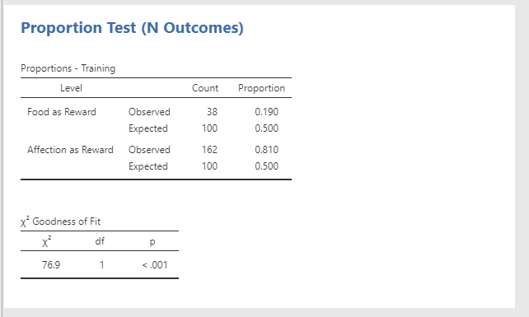
Is this what is wanted???
Any implications of results relevant to discussion section?
Since this is a learning exercise, we won’t spend any time on this. But this would be a good place to record any thoughts on what the results of this test may mean in regard to the study for which this test was conducted. Are any follow-up analyses indicated or does this make you think of questions for other studies which may be conducted in the future?

Honestly, I’m not totally sure what it means that the null was rejected in this care. I had said the null was that animals can’t be taught to dance with food or affection. So, does this mean that they certainly can? Unsure.
Chi-square test of association (aka chi-square test of independence)
What statistical test(s) will be conducted? Which variable(s) will be used in those test(s)?
Chi-square test of association
- Training
- Dance
What are the assumptions for the statistical tests employed? Do the data meet those assumptions?
Refer to Field Chapter 19.5 and Learning Statistics with Jamovi Chapter 10.5.
Independence of residuals (no repeated measures)
Yes
Groups for categorical variables are mutually exclusive.
Yes
All expected counts > 1
No more than 20% of expected counts < 5
Twa
NHST steps (for each test):
- State the null and alternative hypothesis.
- Establish the criteria for rejection (alpha level).
- Calculate the test statistic.
- Draw conclusion about the null.
- Conduct post-hoc analyses if any.
- Report results.
Null and alternative hypotheses
Null: Given food or affection as a reward, house cats will not be able to line dance
Alternative: Given food or affection as a reward, house cats will be able to line dance
Criteria for rejection
There are situations where you may want to use a different alpha level than alpha = .05. If you're doing pilot studies you're mostly looking for trends and possibilities. The alpha level may be relaxed to alpha = .10. If you're doing something like drug studies where there could be negative consequences for false positives the alpha level may be reduced to alpha = .01. We're going to stick to alpha = .05 for class demonstrations.
Calculate test statistic
Calculate the chi-square test of independence.
- Jamovi - Analyses - Frequencies - Contingency Tables - Independent Samples Chi-square test of association.
- Move Training into Rows box and Dance in Columns box.
- Expand the statistics section.
- Make sure the chi-square and Phi and Cramer’s V sections are checked.
- Expand the cells section.
- Make sure observed counts and expected counts are checked.
- What is the value for chi-square?
χ² = 25.4
- What is the value for p?
p = <0.001

Conclusion about the null
Reject
Post-hoc
Phi – used for 2x2 tables
Cramer’s V – used for tables larger than 2x2
👍
Standardized residuals (which cells > |2|)
Calculate the standardized residuals for the cells in RStudio.
What is the value of the standardized residuals for each cell? Which cells are strong contributors to the chi-square result? What does it mean when the standardized residual is positive/negative?
- Food as reward – No -2.799516
- Food as reward – Yes 2.266299
- Affection as reward – No 1.357288
- Affection as reward – Yes -1.7328
- How do you interpret the meaning of these results?

Report results
See Field chapter 19.8.5 for an example of how to report the results of this test. It’s not necessary to write it out here.
There was a significant association between the type of training and whether cats would dance χ2(1) = 25.4, p < 0.001. Standardized residuals for Food as a reward-Yes was 2.267 (an extreme value and higher than expected).

Plots
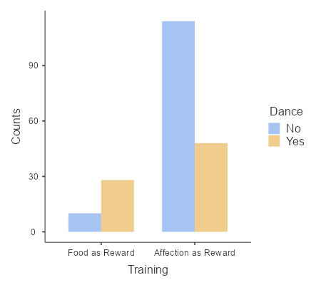

Any implications of results relevant to discussion section?
Since this is a learning exercise, we won’t spend any time on this. But this would be a good place to record any thoughts on what the results of this test may mean in regard to the study for which this test was conducted. Are any follow-up analyses indicated or does this make you think of questions for other studies which may be conducted in the future?
Assignment – Final Steps
Save your Jamovi (.omv) file. You will turn it in.
👍
After you finished reading through the .Rmd file. Knit the file to markdown and save the .md file. You will turn the file in as part of your assignment. Describe any difficulties. If you encounter errors close all instances of RStudio and try opening it again. (Don’t save your workspace.) If you encounter errors while creating the file and can’t figure out how to fix them before the assignment is due. You can paste the text of the .Rmd file with the output into a Word or pdf file and turn in that.
👍
What did you like/dislike about this assignment? How would you change this assignment to make it better for future students?
I liked using the nonparametric tests. They’re neat!

I disliked that I was unclear about what some of the steps meant in terms of what conclusion should be drawn. My suggestion for change is to provide some guidance about that in the cells that ask for a conclusion.
Complete the answer submission in Canvas. Load your RStudio and Jamovi files to your GitHub repository for this assignment. Submit the link to your repository.

